MAC 1105
Project 1. Drawing with the Library of Functions.
Objectives:
- Identify the graphs and characteristics of the following functions:
- $f\left(x\right)=x$
Domain- (-$∞, ∞$)
Range - (-$∞, ∞$)
x – intercepts: (0.0)
y – intercepts: (0.0)

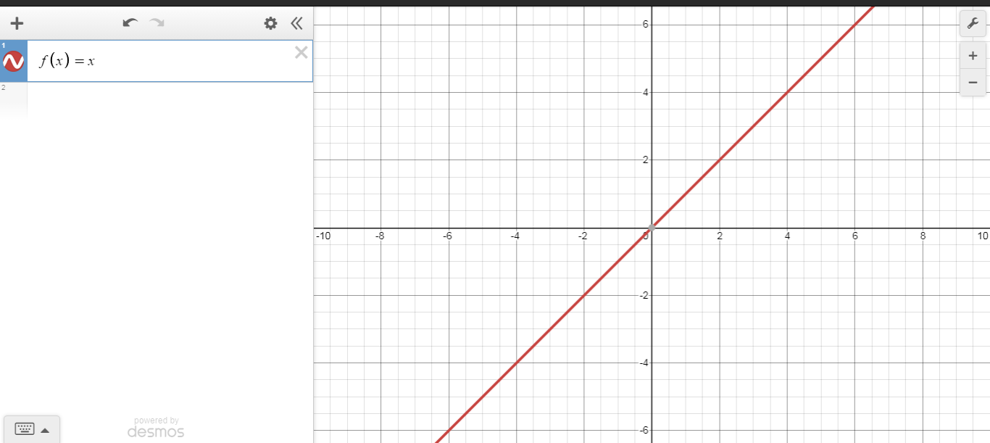
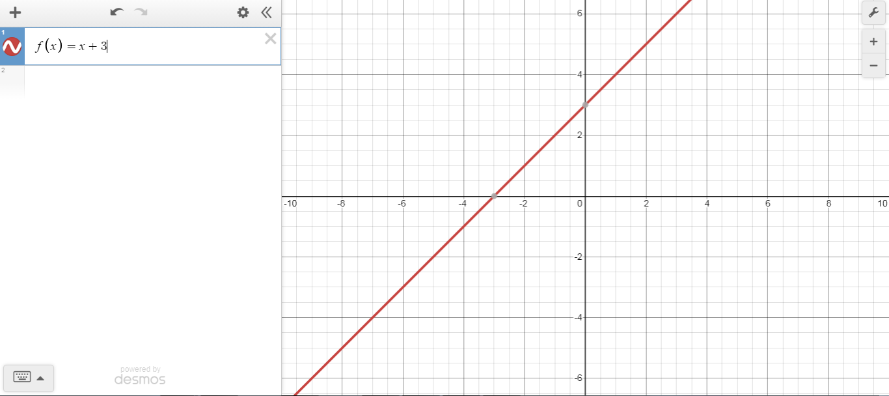
The graph shows the graph of the function x and $x+3$. This example shows the effect of adding a positive constant to the output of the function $x.$ We have a vertical shift of 3 units upward
- $f\left(x\right)=x^{2}$
Domain- (-$∞, ∞$)
Range – [0$, ∞$)
x – intercepts: (0.0)
y – intercepts: (0.0)
axis of symmetry about the origin
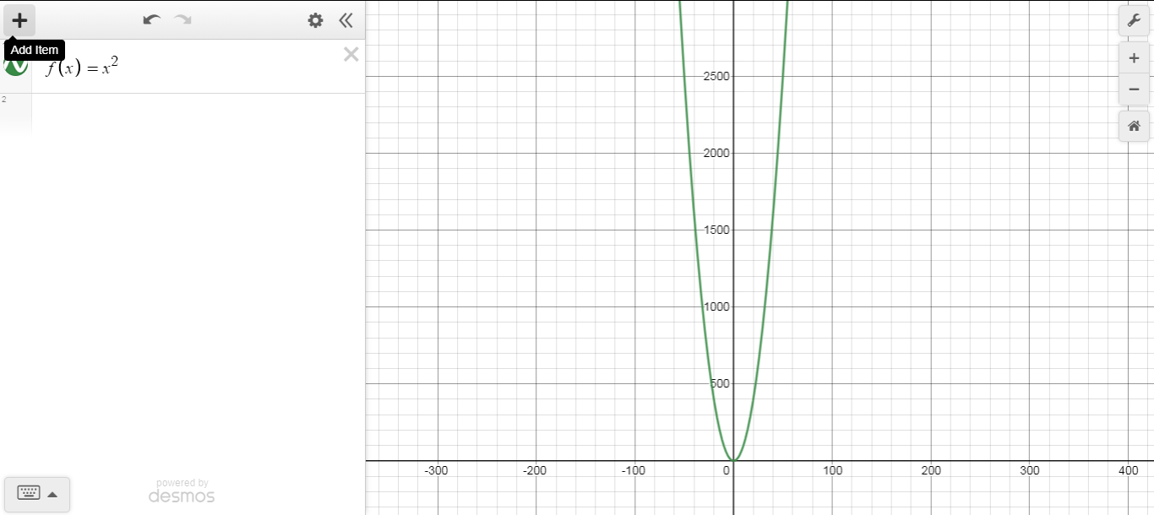
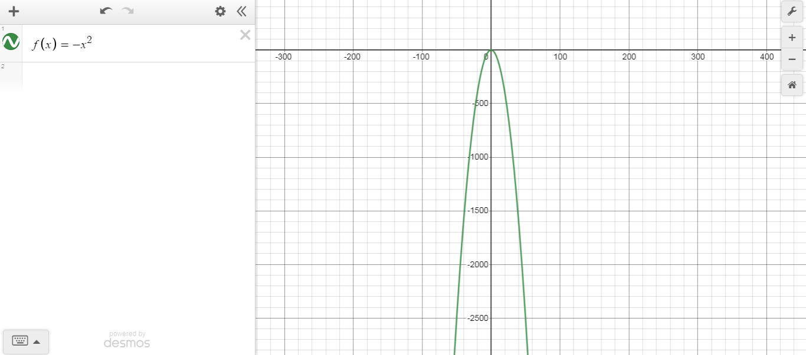
The graph shows the graph of the function x² and $-x^{2}$. This example shows the effect of -a to the output of the function $x^{2}.$ We have a reflection on the x-axis.
- $f\left(x\right)=x^{3}$
Domain- (-$∞, ∞$)
Range - (-$∞, ∞$)
x – intercepts: (0.0)
y – intercepts: (0.0)
axis of symmetry: x = 0
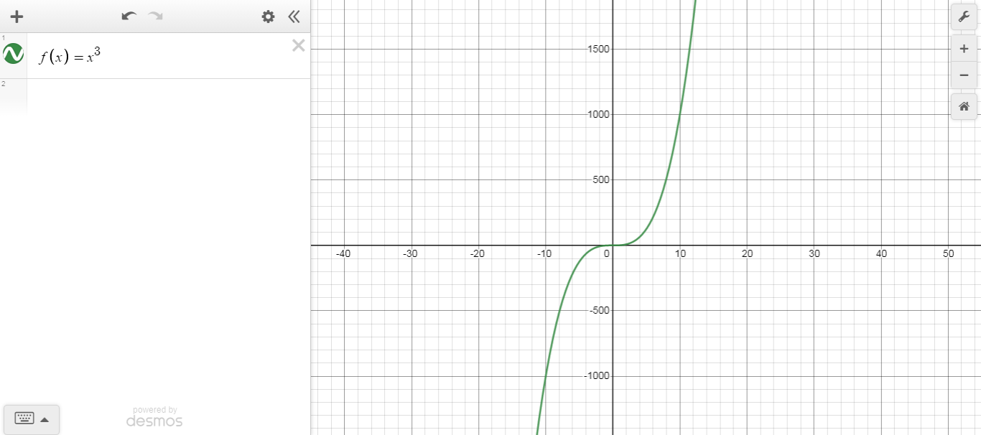
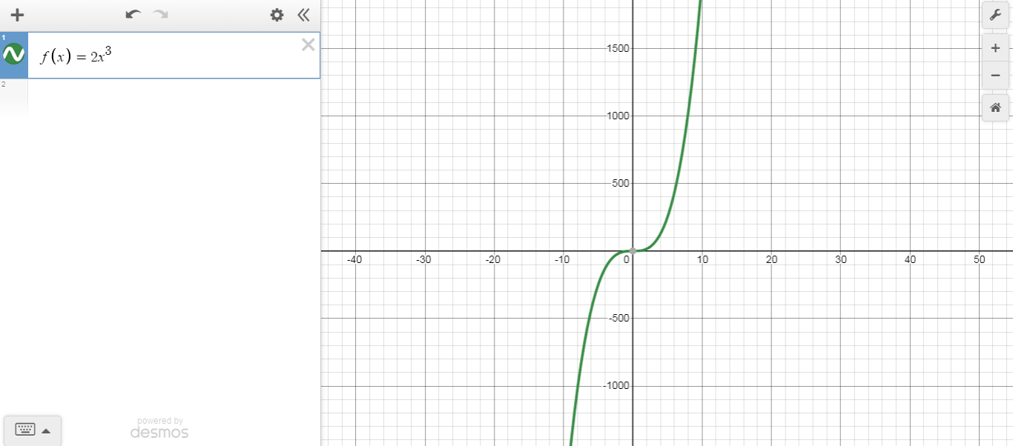
The graph shows the graph of the function x³ and $2x^{3}$. This example shows the effect of 2a to the output of the function $x^{3}.$ We have a horizontal compression by a scale factor of 2.

- $f\left(x\right)=\sqrt{x}$
Domain- [0$, ∞$)
Range - [0$, ∞$)
x – intercepts: (0.0)
y – intercepts: (0.0)
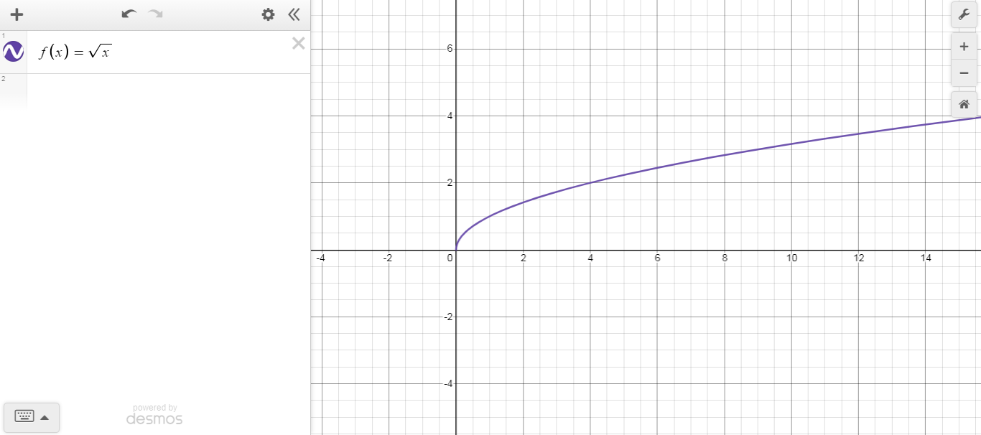
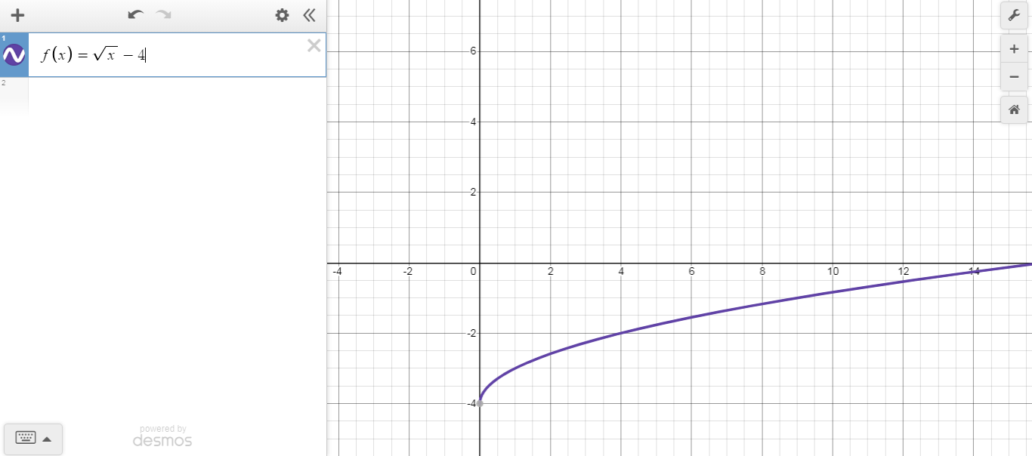
The graph shows the graph of the function $\sqrt{x}$ and $\sqrt{x}-4$. This example shows the effect of adding a negative constant to the output of the function $\sqrt{x}.$ We have a vertical shift of 4 units downward.

- $f\left(x\right)=\sqrt[3]{x}$
Domain- (-$∞, ∞$)
Range - (-$∞, ∞$)
x – intercepts: (0.0)
y – intercepts: (0.0)
axis of symmetry about the origin
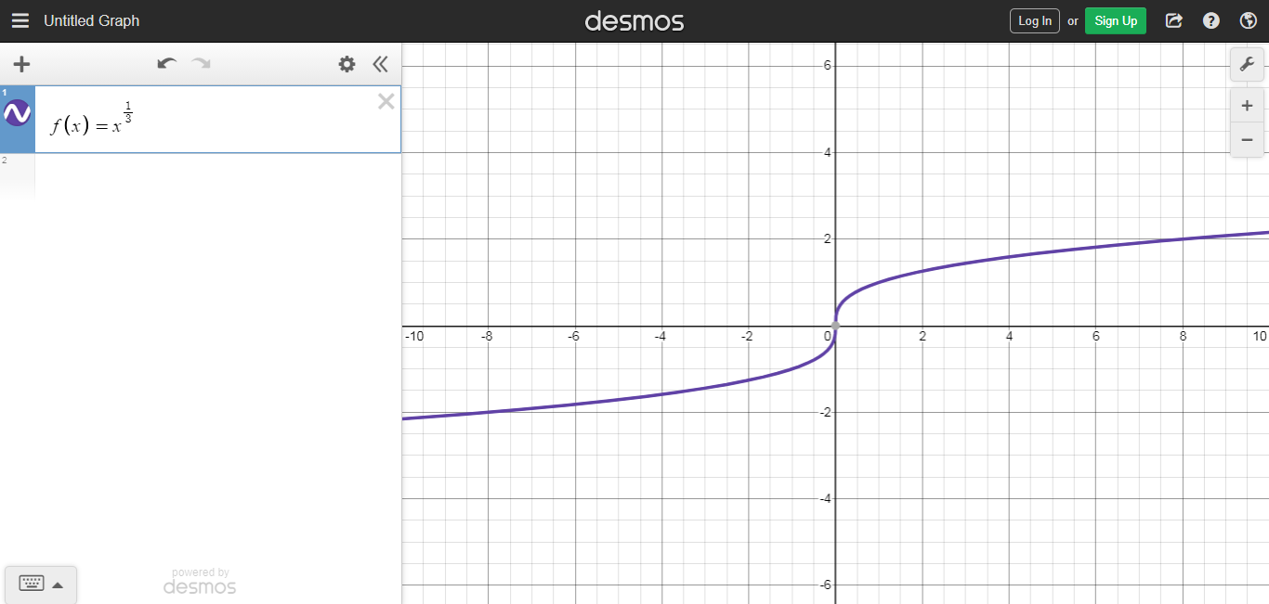
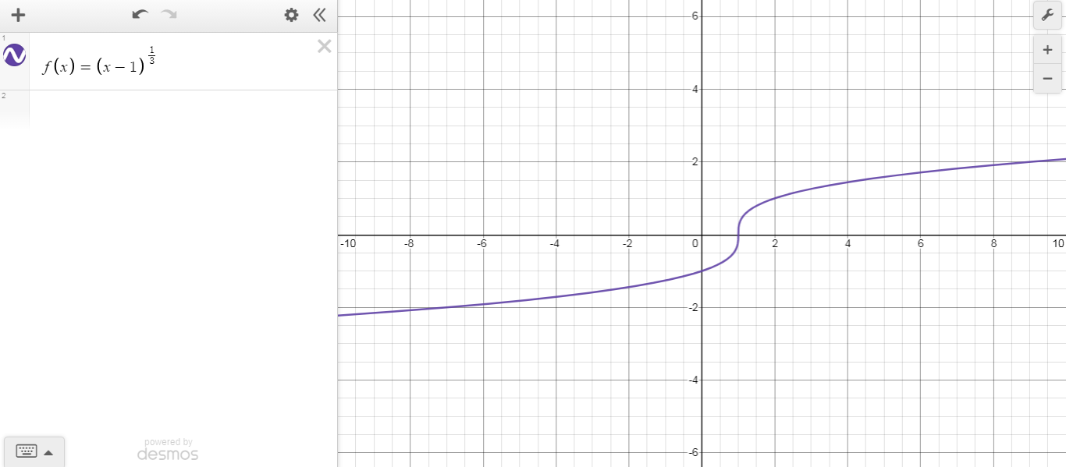
The graph shows the graph of the function $\sqrt[3]{x}$ and $\sqrt[3]{(x-1)}$. This example shows the effect of adding a negative b to the output of the function $\sqrt[3]{x}.$ We have a horrizontal shift of 1 unit to the right.

- $f\left(x\right)=\frac{1}{x}$
Domain- (-$∞, 0$)$∪(0,∞)$
Range - (-$∞, 0$)$∪(0,∞)$
axis of symmetry about the origin
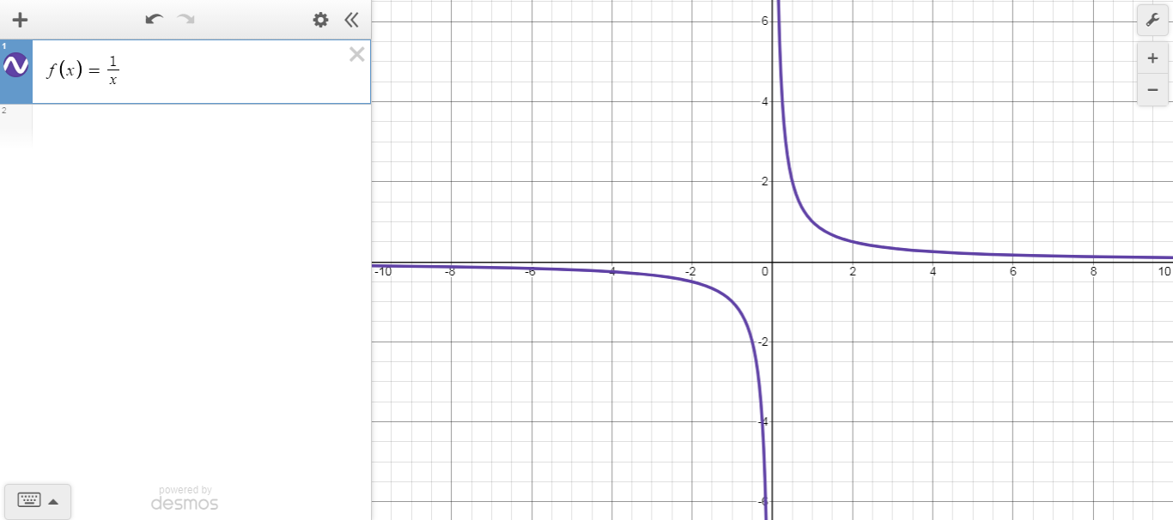
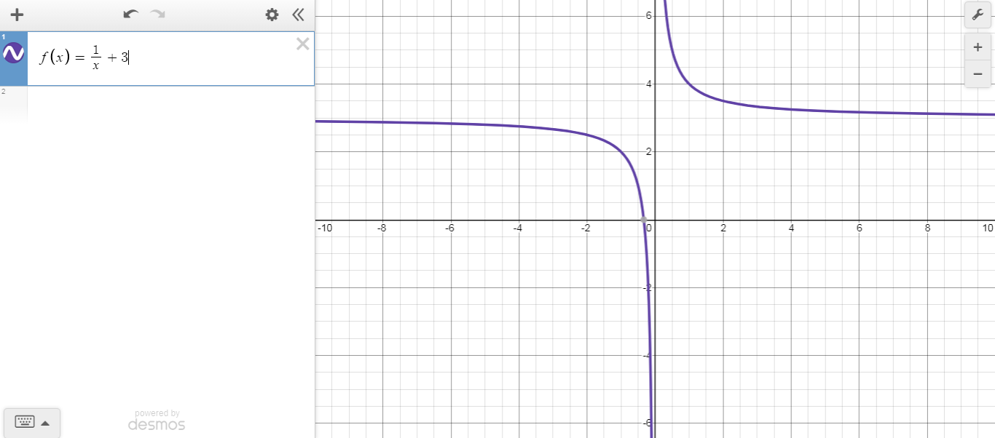
The graph shows the graph of the function $\frac{1}{x}$ and $\frac{1}{x}+3$. This example shows the effect of adding a positive constant to the output of the function $\frac{1}{x}.$ We have a vertical shift of 3 units upward

- $f\left(x\right)=\left|x\right|$
Domain- (-$∞, ∞$)
Range – [0$, ∞$)
x – intercepts: (0.0)
y – intercepts: (0.0)
axis of symmetry about the y - axis
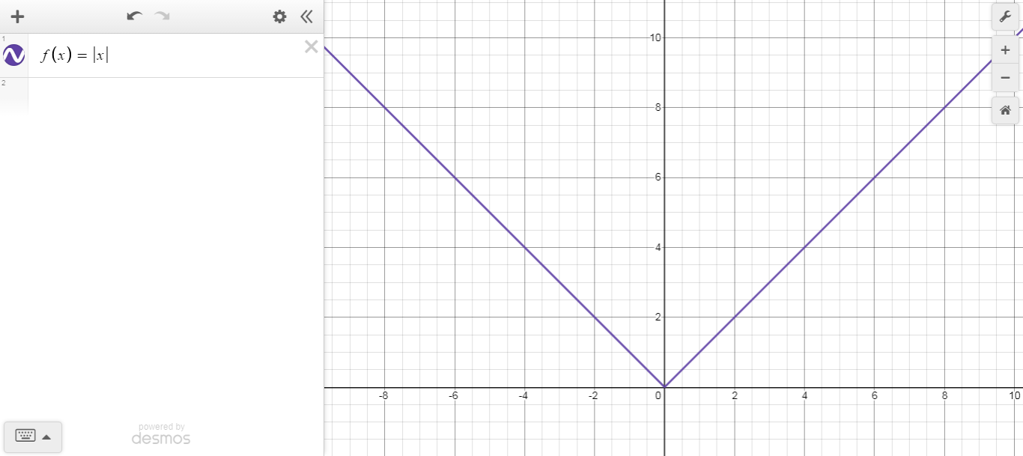
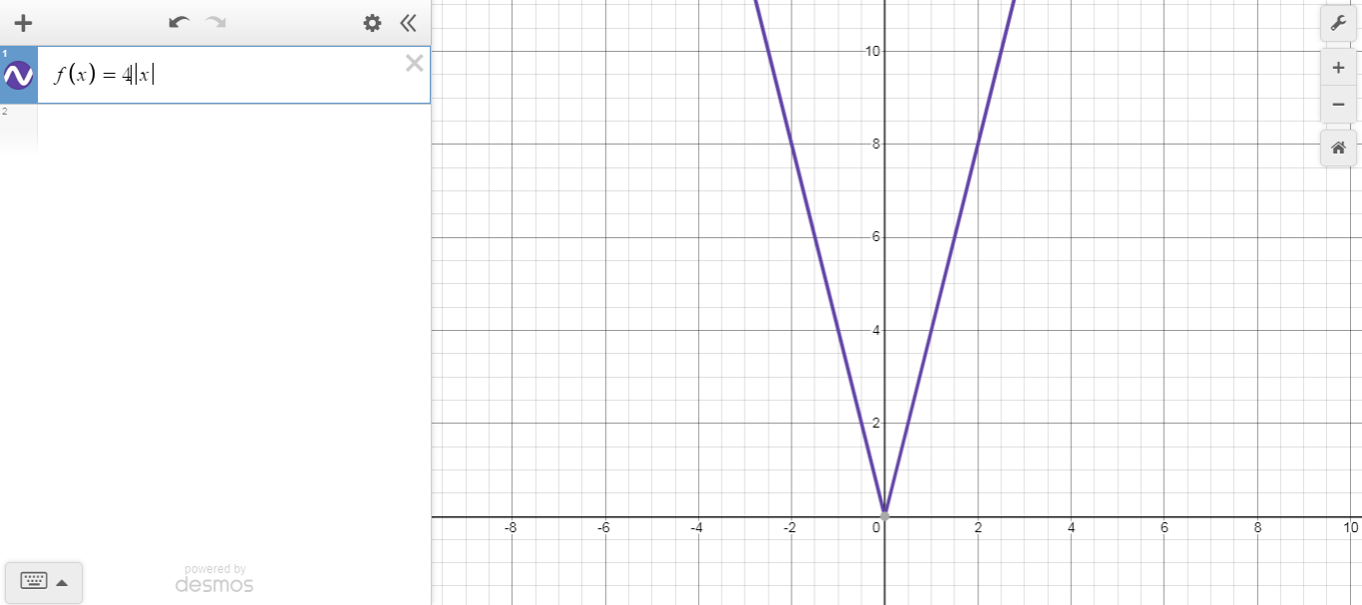
The graph shows the graph of the function $\left|x\right|$ and $4\left|x\right|$This example shows the effect of 2a to the output of the function $\left|x\right|.$ We have a horizontal compression by a scale factor of 4

- $f\left(x\right)=⟦x⟧$ (greatest integer less than x) [ floor(x)]

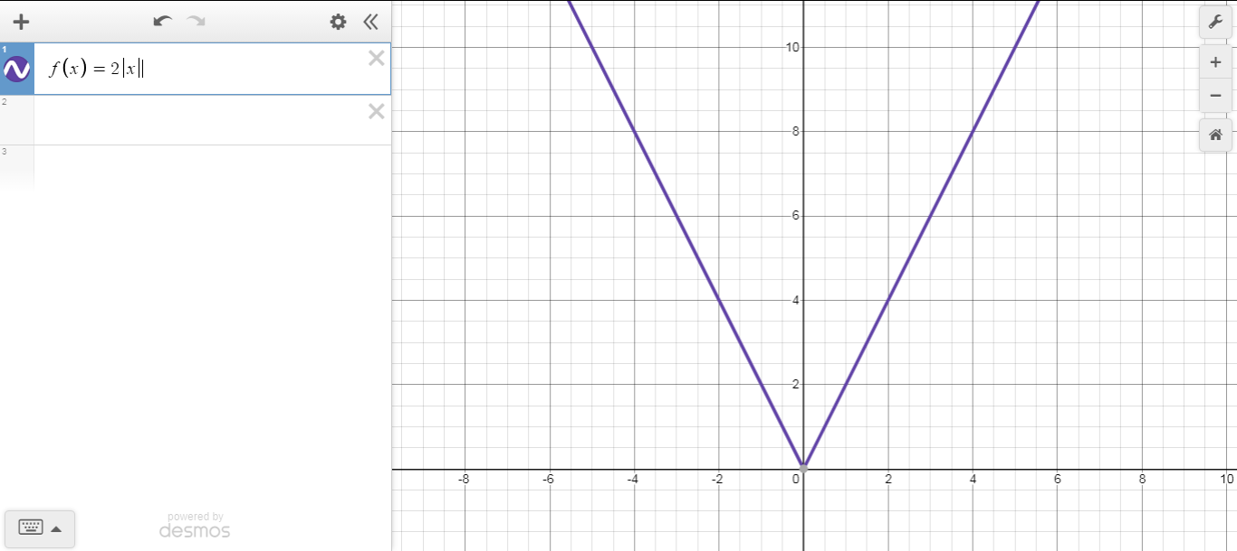
The graph shows the graph of the function $\left|x\right|$ and $2\left|x\right|$This example shows the effect of 2a to the output of the function $\left|x\right|.$ We have a horizontal compression by a scale factor of 2

